Transport Management System (TMS) — Forms, Fields & Process Flow
This document outlines the database entities, form fields, and operational workflows for each module in your Transport Management System.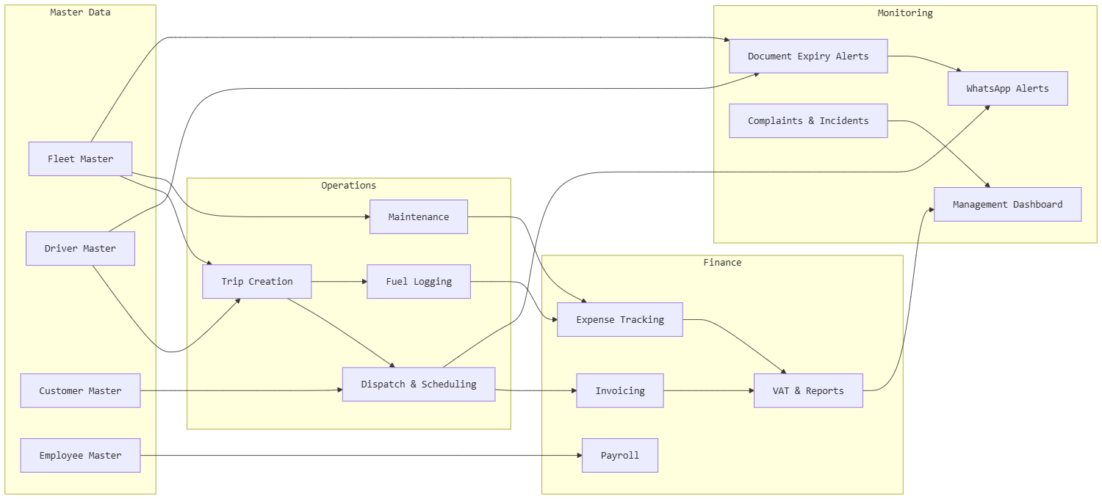

1. Transport Operations Module

1.1 Trip Creation & Scheduling Form
Field Name | Type | Validation / Notes
Trip ID | Auto-generated | Unique identifier
Trip Date | Date | Required
Start Time | Time | Required
End Time (Estimated) | Time | Optional
Origin Location | Dropdown / Text | Required
Destination Location | Dropdown / Text | Required
Customer | Dropdown (Customer Master) | Required
Cargo Type | Dropdown | General, Hazardous, Perishable, etc.
Load Weight (kg) | Number | Optional
Vehicle Assigned | Dropdown (Fleet Master) | Required
Driver Assigned | Dropdown (Driver Master) | Required
Route | Dropdown / Map Selection | Optional
Trip Status | Dropdown | Scheduled, In Progress, Completed, Cancelled
Remarks | Text Area | Optional

1.2 Process Flow

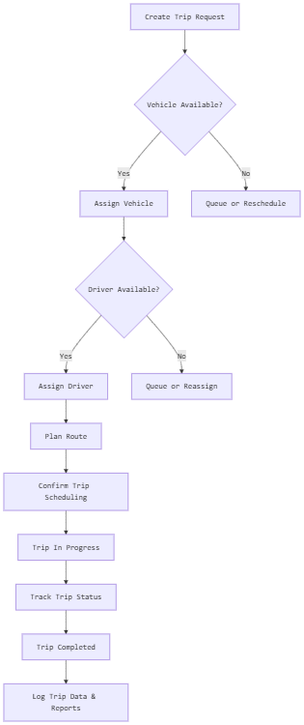
flowchart TD
A[Create Trip Request] --> B{Vehicle Available?}
B -- Yes --> C[Assign Vehicle]
B -- No --> D[Queue or Reschedule]
C --> E{Driver Available?}
E -- Yes --> F[Assign Driver]
E -- No --> G[Queue or Reassign]
F --> H[Plan Route]
H --> I[Confirm Trip Scheduling]
I --> J[Trip In Progress]
J --> K[Track Trip Status]
K --> L[Trip Completed]
L --> M[Log Trip Data & Reports]

2. Fleet Management Module

2.1 Vehicle Master Form
Field Name | Type | Validation / Notes
Vehicle ID | Auto-generated | Unique
Registration Number | Text | Required, Unique
Vehicle Type | Dropdown | Truck, Van, Trailer, etc.
Make / Model | Text | Required
Year of Manufacture | Year | Required
Chassis Number | Text | Unique
Engine Number | Text | Unique
Fuel Type | Dropdown | Diesel, Petrol, Electric, Hybrid
Capacity (tons) | Number | Required
Current Odometer (km) | Number | Required
Registration Expiry Date | Date | Required
Insurance Expiry Date | Date | Required
Permit Expiry Date | Date | Optional
Assigned Yard / Location | Dropdown | Optional
Status | Dropdown | Active, Under Maintenance, Inactive
Documents (Upload) | File | Registration, Insurance, Permit

2.2 Process Flow
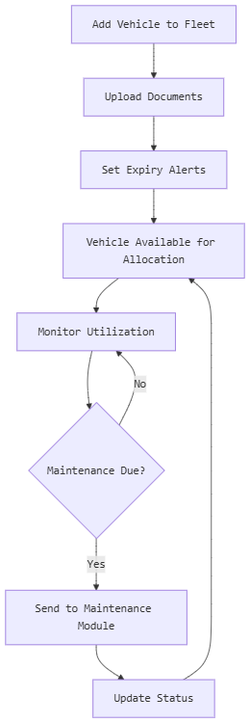
flowchart TD
A[Add Vehicle to Fleet] --> B[Upload Documents]
B --> C[Set Expiry Alerts]
C --> D[Vehicle Available for Allocation]
D --> E[Monitor Utilization]
E --> F{Maintenance Due?}
F -- Yes --> G[Send to Maintenance Module]
F -- No --> E
G --> H[Update Status]
H --> D

3. Dispatch & Scheduling Module

3.1 Dispatch Job Form
Field Name | Type | Validation / Notes
Job ID | Auto-generated | Unique
Job Date | Date | Required
Customer | Dropdown | Required
Pickup Location | Text / Map | Required
Drop Location | Text / Map | Required
Cargo Details | Text Area | Optional
Load Weight | Number | Optional
Priority | Dropdown | Normal, Urgent, Critical
Assigned Trip | Dropdown (Trip Master) | Required
Delivery Status | Dropdown | Pending, Dispatched, In Transit, Delivered
Proof of Delivery (Upload) | File | Optional
Remarks | Text Area | Optional

3.2 Process Flow

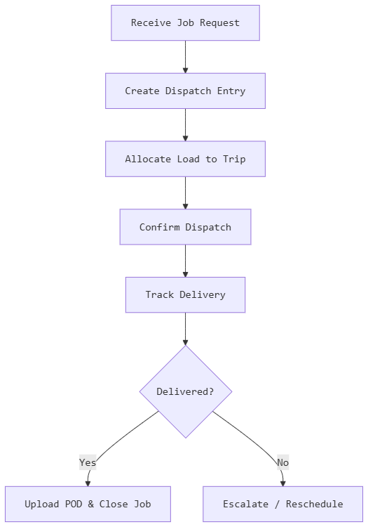flowchart TD
A[Receive Job Request] --> B[Create Dispatch Entry]
B --> C[Allocate Load to Trip]
C --> D[Confirm Dispatch]
D --> E[Track Delivery]
E --> F{Delivered?}
F -- Yes --> G[Upload POD & Close Job]
F -- No --> H[Escalate / Reschedule]

4. Fuel Management Module

4.1 Fuel Entry Form
Field Name | Type | Validation / Notes
Entry ID | Auto-generated | Unique
Vehicle | Dropdown (Fleet Master) | Required
Driver | Dropdown (Driver Master) | Required
Fuel Date | Date | Required
Fuel Station | Text | Optional
Fuel Type | Dropdown | Diesel, Petrol, etc.
Quantity (liters) | Number | Required
Amount (AED) | Number | Required
Odometer Reading | Number | Required
Receipt (Upload) | File | Optional

4.2 Process Flow
flowchart TD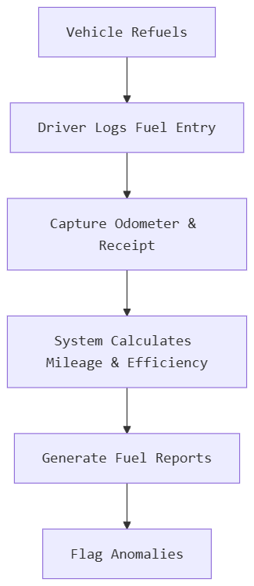
A[Vehicle Refuels] --> B[Driver Logs Fuel Entry]
B --> C[Capture Odometer & Receipt]
C --> D[System Calculates Mileage & Efficiency]
D --> E[Generate Fuel Reports]
E --> F[Flag Anomalies]

5. Vehicle Maintenance Module

5.1 Maintenance Request Form
Field Name | Type | Validation / Notes
Maintenance ID | Auto-generated | Unique
Vehicle | Dropdown | Required
Maintenance Type | Dropdown | Preventive, Corrective, Breakdown
Service Category | Dropdown | Engine, Tires, Brakes, Electrical, etc.
Requested Date | Date | Required
Scheduled Date | Date | Required
Assigned Garage / Technician | Text / Dropdown | Optional
Odometer at Service | Number | Required
Estimated Cost (AED) | Number | Optional
Actual Cost (AED) | Number | Post-completion
Spare Parts Used | Multi-select / Text | Optional
Status | Dropdown | Requested, Scheduled, In Progress, Completed
Service Notes | Text Area | Optional
Invoice (Upload) | File | Optional

5.2 Process Flow

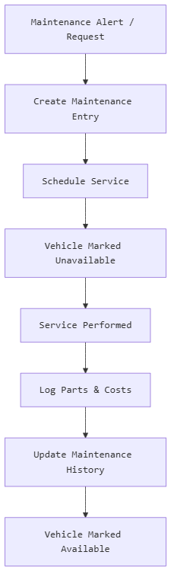
flowchart TD
A[Maintenance Alert / Request] --> B[Create Maintenance Entry]
B --> C[Schedule Service]
C --> D[Vehicle Marked Unavailable]
D --> E[Service Performed]
E --> F[Log Parts & Costs]
F --> G[Update Maintenance History]
G --> H[Vehicle Marked Available]

6. Driver Management Module

6.1 Driver Master Form
Field Name | Type | Validation / Notes
Driver ID | Auto-generated | Unique
Full Name | Text | Required
Mobile Number | Text | Required
Email | Email | Optional
Emirates ID | Text | Required, Unique
License Number | Text | Required, Unique
License Expiry Date | Date | Required
License Type | Dropdown | Light, Heavy, Hazmat, etc.
Date of Joining | Date | Required
Assigned Vehicle | Dropdown | Optional
Status | Dropdown | Active, On Leave, Inactive
Photo (Upload) | File | Optional
Documents (Upload) | File | License copy, ID, etc.

6.2 Driver Performance & Incentive Form
Field Name | Type | Validation / Notes
Driver | Dropdown | Required
Period (Month/Year) | Date | Required
Trips Completed | Number | Auto-calculated
On-Time Deliveries (%) | Percentage | Auto-calculated
Incidents / Violations | Number | From Incident Module
Fuel Efficiency Score | Number | From Fuel Module
Incentive Amount (AED) | Number | Calculated / Manual
Penalty Amount (AED) | Number | Calculated / Manual
Remarks | Text Area | Optional

6.3 Process Flow
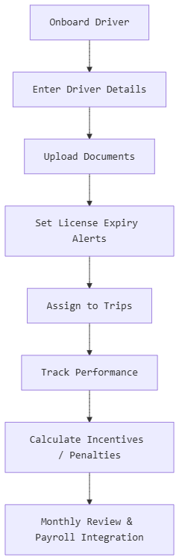
flowchart TD
A[Onboard Driver] --> B[Enter Driver Details]
B --> C[Upload Documents]
C --> D[Set License Expiry Alerts]
D --> E[Assign to Trips]
E --> F[Track Performance]
F --> G[Calculate Incentives / Penalties]
G --> H[Monthly Review & Payroll Integration]

8. Financial & Accounts Module

8.1 Expense Entry Form
Field Name | Type | Notes
Expense ID | Auto-generated | Unique
Expense Category | Dropdown | Fuel, Maintenance, Salaries, Rent, etc.
Expense Date | Date | Required
Amount (AED) | Number | Required
Paid To | Text | Vendor, Employee, etc.
Payment Method | Dropdown | Cash, Bank Transfer, Card
Reference Number | Text | Optional
Linked Vehicle / Trip | Dropdown | Optional
VAT Amount | Number | Auto-calculated or manual
Receipt (Upload) | File | Optional
Remarks | Text Area | Optional

8.2 Invoice Form (Customer Billing)
Field Name | Type | Notes
Invoice ID | Auto-generated | Unique
Customer | Dropdown | Required
Invoice Date | Date | Required
Due Date | Date | Required
Trip / Job References | Multi-select | Required
Subtotal (AED) | Number | Auto-calculated
VAT (5%) | Number | Auto-calculated
Total (AED) | Number | Auto-calculated
Payment Status | Dropdown | Unpaid, Partial, Paid
Remarks | Text Area | Optional

8.3 Report Types
- Profit & Loss Statement — Revenue vs. expenses over a period
- Balance Sheet — Assets, liabilities, equity snapshot
- Cash Flow Statement — Inflows and outflows by category
- VAT Report — Input VAT, Output VAT, Net VAT payable
- Cost Analysis — Per vehicle, per trip, per customer

8.4 Process Flow
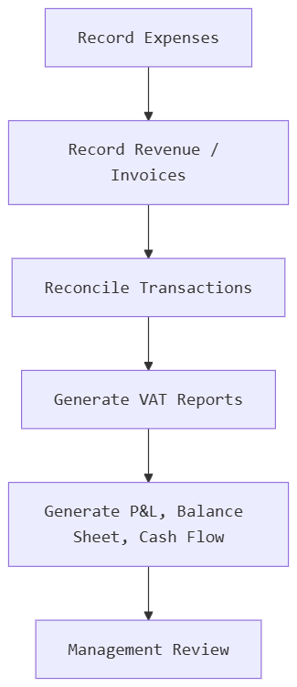
flowchart TD
A[Record Expenses] --> B[Record Revenue / Invoices]
B --> C[Reconcile Transactions]
C --> D[Generate VAT Reports]
D --> E[Generate P&L, Balance Sheet, Cash Flow]
E --> F[Management Review]

9. Management Dashboard

9.1 Dashboard Widgets / KPIs
Widget | Data Source | Notes
Total Revenue (MTD/YTD) | Invoices | Real-time
Total Expenses (MTD/YTD) | Expense Entries | Real-time
Active Vehicles | Fleet Master | Count where Status = Active
Vehicles Under Maintenance | Maintenance Module | Count
Active Drivers | Driver Master | Count
Trips Today | Trip Module | Count
On-Time Delivery % | Dispatch Module | Calculated
Fleet Utilization % | Trips vs. Available Vehicles | Calculated
Fuel Efficiency (km/L) | Fuel Module | Average
Pending Complaints | Complaint Module | Count
Expiring Documents (Next 30 Days) | Document Expiry Module | Alert List

9.2 Process Flow
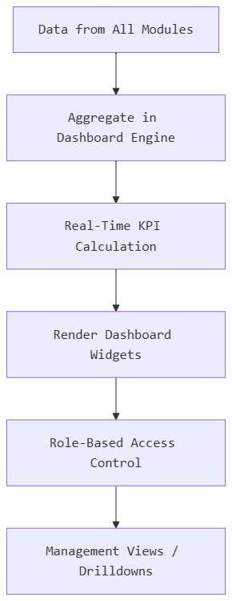
flowchart TD
A[Data from All Modules] --> B[Aggregate in Dashboard Engine]
B --> C[Real-Time KPI Calculation]
C --> D[Render Dashboard Widgets]
D --> E[Role-Based Access Control]
E --> F[Management Views / Drilldowns]

10. Complaint & Incident Management Module

10.1 Complaint / Incident Form
Field Name | Type | Notes
Complaint ID | Auto-generated | Unique
Date & Time | DateTime | Required
Reported By | Dropdown | Customer, Driver, Staff
Type | Dropdown | Complaint, Incident, Accident
Category | Dropdown | Delivery Delay, Damage, Behavior, Accident, etc.
Linked Trip / Vehicle / Driver | Dropdowns | Optional
Description | Text Area | Required
Risk Level | Dropdown | Low, Medium, High, Critical
Status | Dropdown | Open, In Progress, Resolved, Escalated
Assigned To | Dropdown (Staff) | Optional
Resolution Notes | Text Area | Post-resolution
Attachments (Upload) | File | Photos, documents

10.2 Process Flow
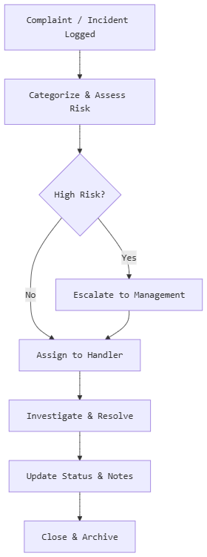
flowchart TD
A[Complaint / Incident Logged] --> B[Categorize & Assess Risk]
B --> C{High Risk?}
C -- Yes --> D[Escalate to Management]
C -- No --> E[Assign to Handler]
D --> E
E --> F[Investigate & Resolve]
F --> G[Update Status & Notes]
G --> H[Close & Archive]

11. Customer Management Module

11.1 Customer Master Form
Field Name | Type | Notes
Customer ID | Auto-generated | Unique
Company Name | Text | Required
Contact Person | Text | Required
Mobile Number | Text | Required
Email | Email | Required
Address | Text Area | Required
TRN (Tax Registration Number) | Text | For VAT invoicing
Contract Start Date | Date | Optional
Contract End Date | Date | Optional
Contract Document (Upload) | File | Optional
Credit Limit (AED) | Number | Optional
Payment Terms (Days) | Number | e.g., 30 days
Status | Dropdown | Active, Inactive

11.2 Customer Follow-Up Form
Field Name | Type | Notes
Follow-Up ID | Auto-generated | Unique
Customer | Dropdown | Required
Follow-Up Date | Date | Required
Purpose | Dropdown | Payment, Renewal, Feedback, Issue
Notes | Text Area | Required
Next Follow-Up Date | Date | Optional
Assigned To | Dropdown (Staff) | Optional

11.3 Process Flow
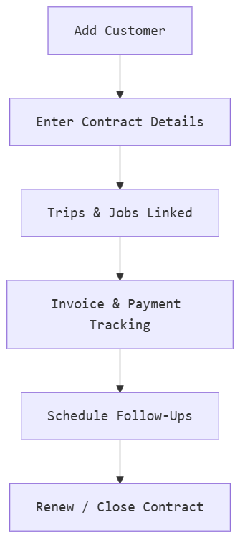
flowchart TD
A[Add Customer] --> B[Enter Contract Details]
B --> C[Trips & Jobs Linked]
C --> D[Invoice & Payment Tracking]
D --> E[Schedule Follow-Ups]
E --> F[Renew / Close Contract]

12. Document Expiry Management Module

12.1 Document Tracker Form
Field Name | Type | Notes
Document ID | Auto-generated | Unique
Document Type | Dropdown | Vehicle Registration, Insurance, Permit, Driver License
Linked Entity | Dropdown | Vehicle or Driver
Issue Date | Date | Required
Expiry Date | Date | Required
Document (Upload) | File | Required
Alert Days Before Expiry | Number | e.g., 30, 15, 7
Status | Dropdown | Valid, Expiring Soon, Expired

12.2 Process Flow
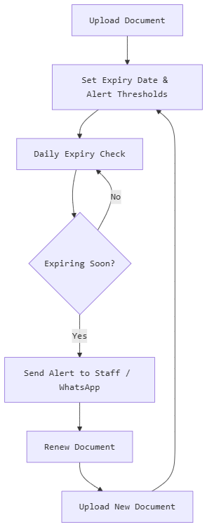
flowchart TD
A[Upload Document] --> B[Set Expiry Date & Alert Thresholds]
B --> C[Daily Expiry Check]
C --> D{Expiring Soon?}
D -- Yes --> E[Send Alert to Staff / WhatsApp]
D -- No --> C
E --> F[Renew Document]
F --> G[Upload New Document]
G --> B

13. WhatsApp Integration

13.1 Alert Configuration Form
Field Name | Type | Notes
Alert Type | Dropdown | Document Expiry, Trip Update, Delivery Confirmation, etc.
Recipient Type | Dropdown | Customer, Driver, Staff
Recipient Number | Phone | Required
Message Template | Text Area | Supports placeholders
Trigger Event | Dropdown | Linked to system events
Status | Toggle | Active / Inactive

13.2 Process Flow
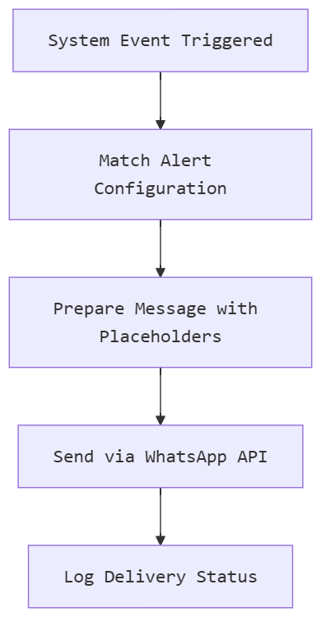
flowchart TD
A[System Event Triggered] --> B[Match Alert Configuration]
B --> C[Prepare Message with Placeholders]
C --> D[Send via WhatsApp API]
D --> E[Log Delivery Status]

14. Accounts & Compliance Module

14.1 VAT Report Form
Field Name | Type | Notes
Report Period | Month/Year | Required
Total Sales (AED) | Number | Auto-calculated
Output VAT (5%) | Number | Auto-calculated
Total Purchases (AED) | Number | Auto-calculated
Input VAT (5%) | Number | Auto-calculated
Net VAT Payable | Number | Output − Input
Report Status | Dropdown | Draft, Submitted, Filed

14.2 Compliance Checklist
- Vehicle Registrations Valid
- Insurance Policies Active
- Driver Licenses Valid
- Permits Up-to-Date
- VAT Filed on Time

15. Operational Enhancements

15.1 Yard Allocation Form
Field Name | Type | Notes
Yard ID | Auto-generated | Unique
Yard Name | Text | Required
Location | Text / GPS | Required
Capacity (Vehicles) | Number | Required
Current Occupancy | Number | Auto-updated
Status | Dropdown | Active, Inactive

15.2 Driver Duty Allocation Form
Field Name | Type | Notes
Allocation ID | Auto-generated | Unique
Driver | Dropdown | Required
Duty Date | Date | Required
Shift | Dropdown | Morning, Evening, Night
Assigned Vehicle | Dropdown | Required
Status | Dropdown | Scheduled, On Duty, Off Duty

15.3 Vehicle Availability Status
Field Name | Type | Notes
Vehicle | Dropdown | Required
Date | Date | Required
Status | Dropdown | Available, Allocated, Under Maintenance, Out of Service
Notes | Text Area | Optional

Overall System Flow Diagram
flowchart LR
subgraph Master Data
A1[Fleet Master]
A2[Driver Master]
A3[Customer Master]
A4[Employee Master]
end
subgraph Operations
B1[Trip Creation]
B2[Dispatch & Scheduling]
B3[Fuel Logging]
B4[Maintenance]
end
subgraph Finance
C1[Expense Tracking]
C2[Invoicing]
C3[Payroll]
C4[VAT & Reports]
end
subgraph Monitoring
D1[Document Expiry Alerts]
D2[Complaints & Incidents]
D3[Management Dashboard]
D4[WhatsApp Alerts]
end
A1 --> B1
A2 --> B1
A3 --> B2
B1 --> B2
B1 --> B3
A1 --> B4
B2 --> C2
B3 --> C1
B4 --> C1
A4 --> C3
C1 --> C4
C2 --> C4
A1 --> D1
A2 --> D1
D1 --> D4
B2 --> D4
D2 --> D3
C4 --> D3

